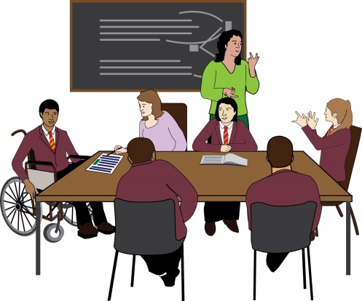
Who is the Alliance for Inclusive Education?
We are led by disabled people. We campaign for inclusive education. This means disabled people having the support they need to learn with everyone in mainstream schools.
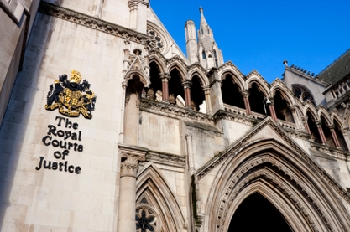
We are supporting a court case about disabled people’s right to mainstream education. This is about disabled and non-disabled pupils being able to learn together in schools for everyone.


Date Wednesday and Thursday 26th and 27th June
Time 9.00 am onwards
Place Royal Court of Justice
Strand, Holborn, London WC2A 2LL
Map: https://goo.gl/maps/4EcGXcRFdH7XrpJe7
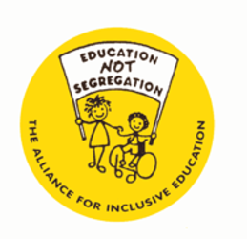
More information
Contact : Simone Aspis
Telephone number : 0207-737-6030
Email address : simone.aspis@allfie.org.uk

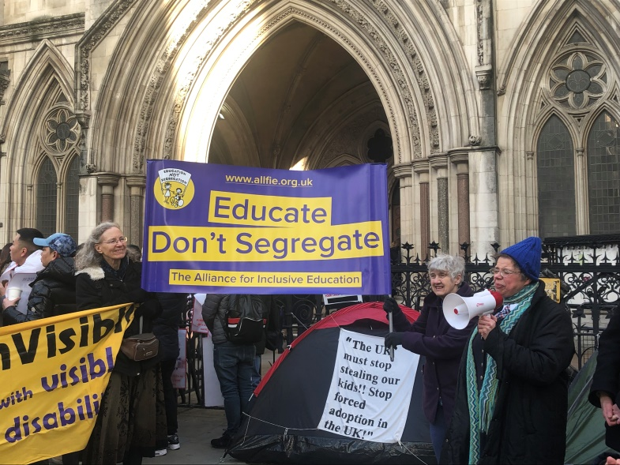
What we want you to do
We want as many of you as possible to be outside and inside the court room. We need the judge to see how much support there is for families wanting good funded support for their disabled children in mainstream schools.

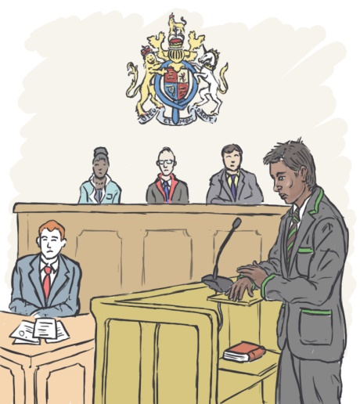
The court case
There are three families with disabled pupils who have not got the support they need in school. The families are saying that cuts in funding for schools and Special Educational Needs help means the Government is:

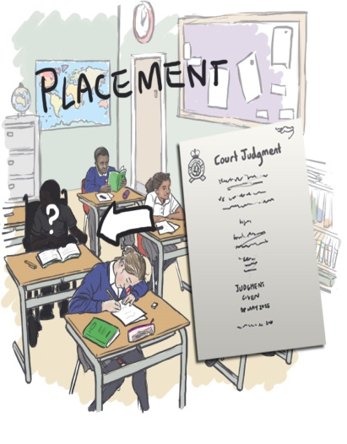
• Discriminating against disabled pupils in school.
• Breaking disabled pupils’ right to be treated equally in education

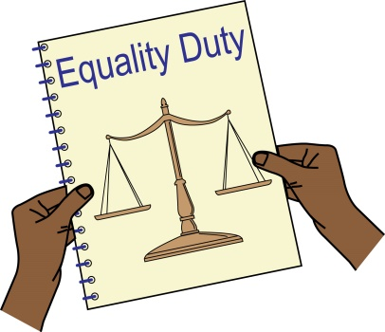
Equality Act Equality Duty
This is a law for public bodies telling them they must think about how their work supports equality when making decisions such as spending money. For more information: https://assets.publishing.service.gov.uk/government/uploads/system/uploads/attachment_data/file/85039/easy-read.pdf

In this court case, the Government must think about whether the money they give to schools and Special Educational Needs will not stop disabled pupils being treated equally in school.


European Convention on Human Rights (ECHR)
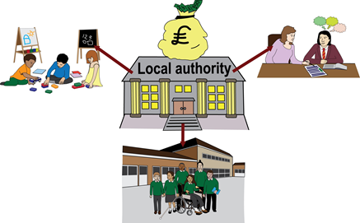
The Human Rights Act says that Government must promote human rights under the European Convention on Human Rights. This includes disabled people’s right to mainstream education.

The Government’s decision about schools and Special Educational Needs help funding should ensure disabled and non-disabled pupils are treated equally in education.
https://www.equalityhumanrights.com/en/file/7061/download?token=l7ghY_ab


UN Convention for Persons with Disabilities
The UN Convention is an agreement between different countries about disabled people’s rights. (For more information see https://www.equalityhumanrights.com/sites/default/files/uncrpd_guide_easyread.pdf)
Disabled people have a human right to inclusive school, college and university education.

